**National University of Computer and Emerging Sciences**



**Laboratory Tasks 06**

*for*

# Web Engineering

*Instructor: Saqib Ameer*

*Email: saqib.ameer@nu.edu.pk*

# Spring 2024

**FAST School of Computer Science**

**Syntax for nodejs**

**Server.js**

**Const express = require(“express”)**

**Const path = require(“path”)**

**Const bodyparser = require(“body-parser”)**

**Const app = express();**

**Const port = 3003;**

**App.use(bodtparser.urlencoded({extended:true}));**

**App.use(express.static(path.join(__dirname , “public”)));**

**App.get(“/” , (req , res) =>{**

**Res.sendfile(path.join(__dirname , “public” , “index.html”));**

**});**

**App.post(“/login” , (req , res) =>{**

**Const {username , password} = req.body**

**//Code here});**

**App.listen(port , ()=>{**

**Console.log(`Server is running at http://localhost:${port}`);**

**})**

**// For making and exporting modules A string variable**

**const myMessage = "Hello from FAST NU!";**

**// A function that displays the message**

**function displayMessage() {**

**console.log(myMessage);}**

**// Export the function and the variable**

**module.exports = {**

**displayMessage,**

**myMessage,};**

**const http = require('http');**

**const myModule = require('./myModule'); // Import your custom module**

**// Create an HTTP server**

**const server = http.createServer((req, res) => {**

**// Set the response header with content type**

**res.setHeader('Content-Type', 'text/plain');**

**// Call the function from your custom module**

**myModule.displayMessage();**

**// Send a response with the message variable from your module**

**res.send(`Message from myModule: ${myModule.myMessage}\n`);**

**});**

**// Listen on port 3000**

**const PORT = 3000;**

**server.listen(PORT, () => {**

**console.log(`Server is listening on port ${PORT}`);**

**});**

**For template engine ejs**

app.set("view engine", "ejs");

app.set("views", path.join(__dirname, "views"));

**Required packages express ejs bodyparser**

**Lab Task 1**:

Download and Install the Node JS in your end device and check current version of your installed package.

**Place screenshot of the current version.**

**Lab Task 2**:

Write first hello world program using Node JS environment in your editor.

**Place code, screenshot of commands to execute and output.**

**Lab Task 3**:

Create your own SERVER using http module in Node JS and print a message “I am your server” into your own server.

**Lab Task 4**:

Write the commonly used HTTP status codes with their meaning, and also commonly used Port numbers.

Write nodejs program in which use different http stutus codes used with menaing Like given

http 200 success ok

http 404 Not found

http 500 Internal Server Error

http 400 Error Bad Request

**Lab Task 5**:

Develop your own Module using Node JS having a function and a string variable that should display any message and include your package in to your own server.

**Place code, screenshot of commands to execute and output.**

**Lab Task 6**:

Revise the **Task3** using **Anonymous** functions.

**Place code, screenshot of commands to execute and output.**

**Lab Task 7**:

Create five packages of different name of cities of Pakistan, create string variable in each module to store city name. Create your new server and include all your modules, and display the name of cities of Pakistan.

**Note:** Each city string should be in separate module, and there should be single executing file.

**Lab Task 8**:

Create the server to perform the arithmetic calculation (+, -, *, /) on variables x=10 and y=5.

**Note:** Each operation should be in separate module, add all 4 modules in your server file and display the result in Console.

**Place code, screenshot of commands to execute and output.**

Lab Task 9:

Make a Login form using html and css for styling form response is handle through html req and res so you need to make this in nodejs using express.js as the server framework.

Output is that validate username and password like if username is saqib and password is 123 then form is submitted otherwise alert box show that username is not valid.

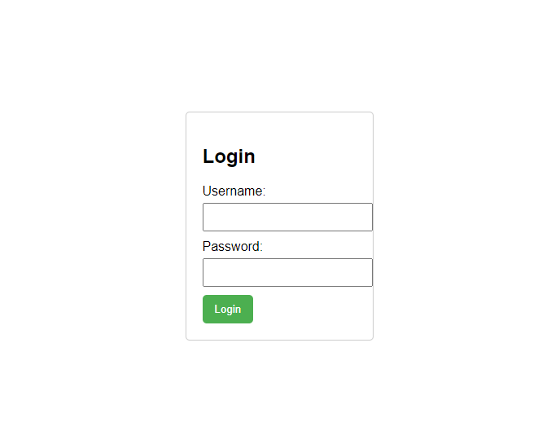

**Lab Task 10:**

Make a simple BMI (Body Mass Index) calculator using HTML for the frontend, CSS for styling, and Node.js for the server. Use Express.js as the server framework and EJS as the template engine. Files required index.ejs style.css server.js package.json

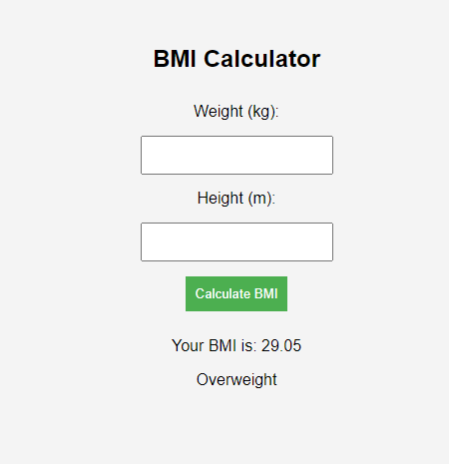

**You are done with your exercise(s), make your submission on Classroom.**

**BEST WISHES**